**Install and use Opencv in QtCreator**

Author: Rafael Guimaraes de Paula

**Installing Qt Framework and QtCreator**  
  
Get the installer from this link: <https://www.qt.io/download-open-source/>  
  
Make sure that the website is detecting your current OS.

  
  
In this tutorial, we will use the following installer: qt-unified-linux-x64-2.0.3-online.run  
Just execute the installer and the following window will be opened:

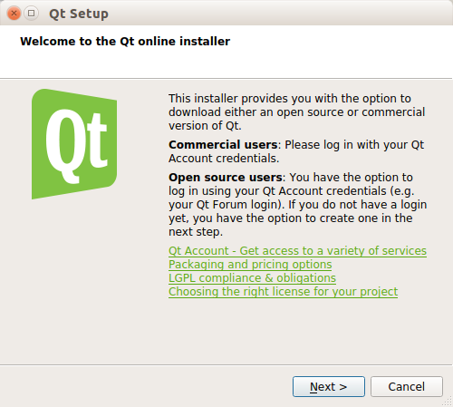

Keep going with the installation and, on the setup window, make sure that the IDE QtCreator will be installed:

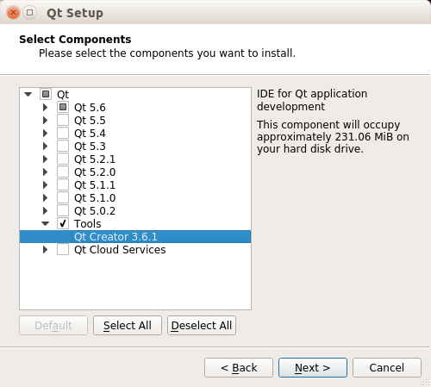

Continue the installation. The program will download and install automatically from this point.

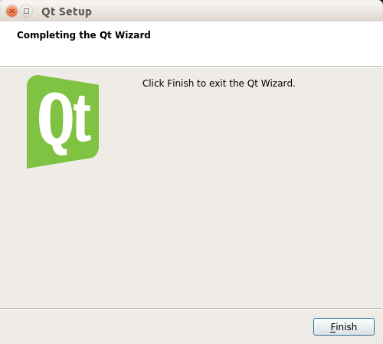

**Installing OpenCV**

First, install all the dependencies using this command on the terminal:  
  
sudo apt-get -y install libopencv-dev build-essential cmake git libgtk2.0-dev pkg-config python-dev python-numpy libdc1394-22 libdc1394-22-dev libjpeg-dev libpng12-dev libtiff4-dev libjasper-dev libavcodec-dev libavformat-dev libswscale-dev libxine-dev libgstreamer0.10-dev libgstreamer-plugins-base0.10-dev libv4l-dev libtbb-dev libqt4-dev libfaac-dev libmp3lame-dev libopencore-amrnb-dev libopencore-amrwb-dev libtheora-dev libvorbis-dev libxvidcore-dev x264 v4l-utils unzip

Use these to download OpenCV 3.0.0 alpha:

mkdir opencv

cd opencv

wget https://github.com/Itseez/opencv/archive/3.0.0-alpha.zip -O opencv-3.0.0-alpha.zip

unzip opencv-3.0.0-alpha.zip

Install the OpenCV:

cd opencv-3.0.0-alpha

mkdir build

cd build

cmake -D CMAKE_BUILD_TYPE=RELEASE -D CMAKE_INSTALL_PREFIX=/usr/local -D WITH_TBB=ON -D WITH_V4L=ON -D WITH_OPENGL=ON ..

make -j $(nproc)

sudo make install

Wait until the installation finishes. Finally, to get OpenCV working properly, use this command:

sudo /bin/bash -c 'echo "/usr/local/lib" > /etc/ld.so.conf.d/opencv.conf'

sudo ldconfig

Reboot your system. The OpenCV installation is finished.

**Using OpenCV on QtCreator**

The first step is to create a new Qt project. Create a new Qt Widget Application:

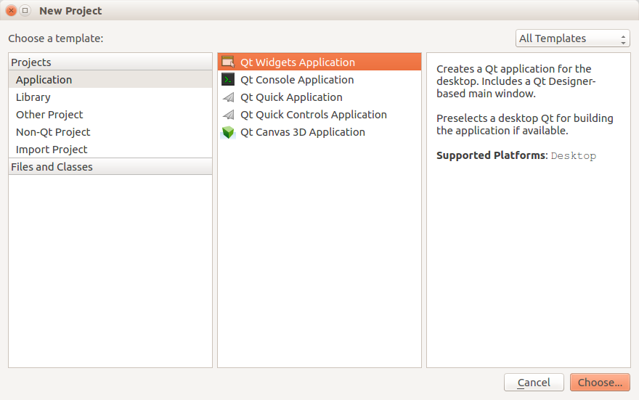

Use all the default options to create the new project. After this, open the .pro file on the project and add the following lines before “SOURCES”:  
  
INCLUDEPATH += /usr/local/include/opencv

LIBS += -L/usr/local/lib -lopencv_core -lopencv_highgui

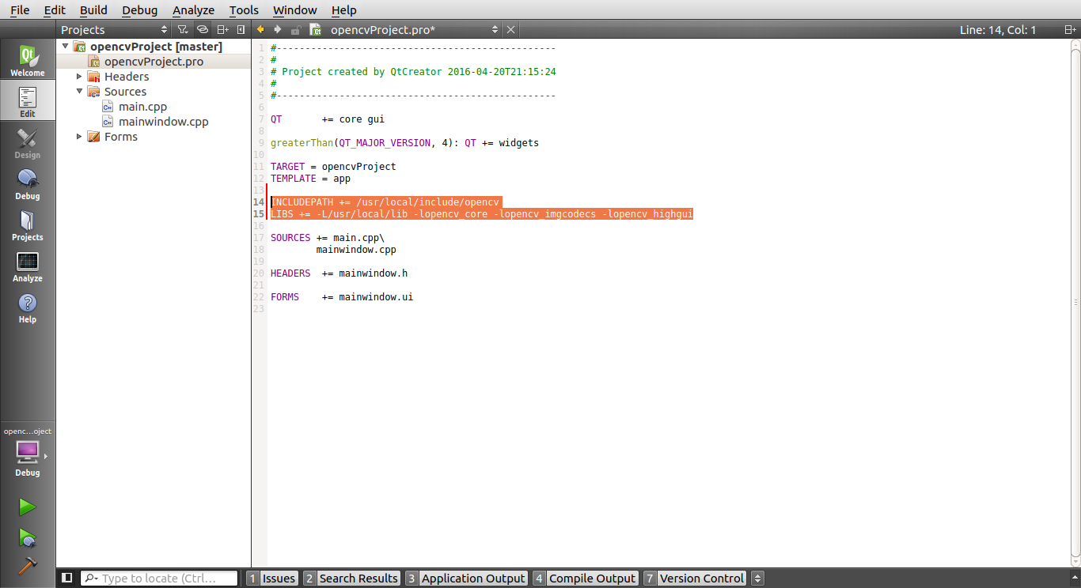

Remember to add all the libraries that you will use on this file, just like the core, imgcodecs and highgui libraries on this example. Now you are ready to use OpenCV in your project.

To make a test, use the following code and change the path in the cv::imread( ) to another valid image path from your computer. Don’t forget to include the opencv library in the main file.  
  
#include "opencv2/opencv.hpp"

int main(int argc, char *argv[])

{

cv::Mat inputImage = cv::imread("/home/opencv/Desktop/logo.jpg");

if(!inputImage.empty())

cv::imshow("Display Image", inputImage);

else

std::cout<<"Failed to display the image";

cv::waitKey(0);

return 0;

}

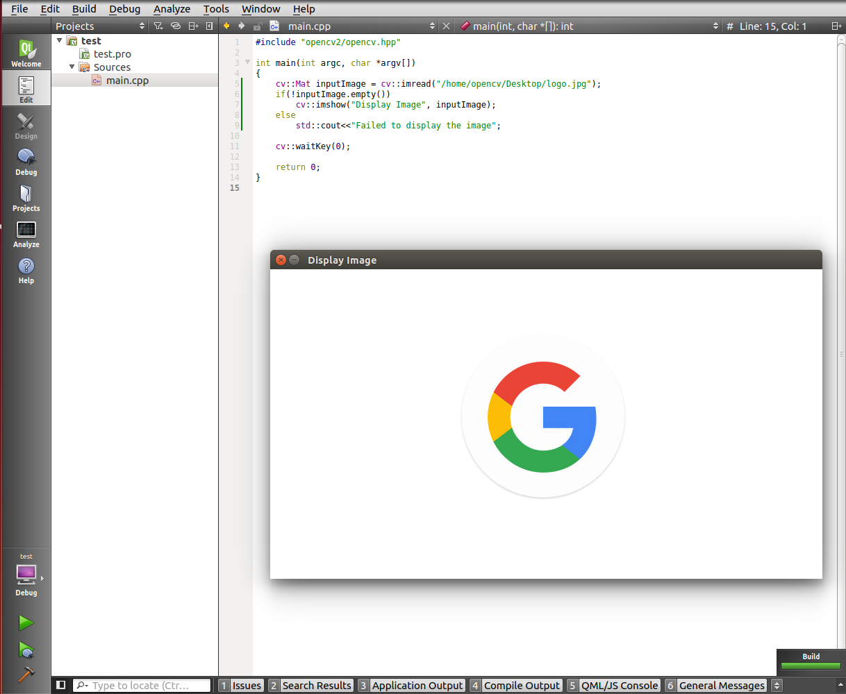

Compile and run the program and if the image is successfully displayed, the OpenCV was installed correctly.